Gospel Reflection:  Advent is the season of hope, ending with the birth of Jesus, bringing the good news that we are loved unconditionally by God. The gospel this week reminds us that one day Jesus will return. This is a good time of year to make a fresh start, get rid of everything negative in our lives, focussing only on the positives so that we are ready to welcome the Lord filled with hope. On the Advent wreath, a candle is lit each Sunday to bring us closer to the light of Jesus at Christmas. The first Advent candle is a symbol of hope. Even though we do not know the exact time when Jesus will come again, He tells us that we need to be ready. We have to wait and watch for Him.  In the gospel Jesus tells us to stay awake while we are waiting, so that we will be ready when He comes. |   Gospel: 1st Sunday of Advent Year B  STAY AWAKE! BE READY!  Jesus said to his disciples: ‘Be on your guard, stay awake, because you never know when the time will come. It is like a man travelling abroad: he has gone from home, and left his servants in charge, each with his own task; and he has told the doorkeeper to stay awake. So, stay awake, because you do not know when the master of the house is coming, evening, midnight, cockcrow, dawn; if he comes unexpectedly, he must not find you asleep. And what I say to you I say to all: Stay awake!’ Mark 13:33-37  ‘Advent is like springtime, when everything is renewed and so is fresh and healthy.’ (St Mother Teresa) | 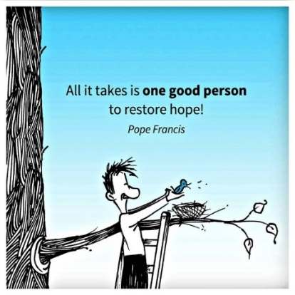  Post-it Challenge:  Write one small action that will help you bring hope to someone in your life today.  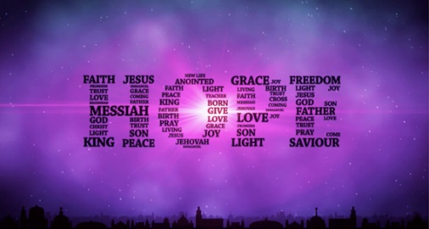  Choose your favourite words from the image.    Explain why these words stand out to you.  Isaiah tells us not to panic when everything is going wrong because God is with us.  - How can you behave differently today to make sure that you have the best possible day with your family, your friends, your teachers?  - As your actions show that you are trying to ‘stay awake’, how can you make sure that those around you also have a good day?
An Advent prayer
In this season of Advent,
as we wait in joyful hope
for the coming of your Son
Let us take time to pause in our busy lives, to prepare our hearts and minds.
Let your light shine within us
So that through our actions we may show hope and kindness to everyone we meet, especially to those in need. Amen

The liturgical colour for Advent is purple. It is also the colour of the royalty and the sovereignty of Christ, as King of Heaven and King of our hearts.

