Gospel: 2nd Sunday of Advent Year B  The beginning of the Good News about Jesus Christ, the Son of God. It is written in the book of the prophet Isaiah:  Look, I am going to send my messenger before you;  he will prepare your way.  A voice cries in the wilderness:  Prepare a way for the Lord, make His paths straight.    And so, it was that John the Baptist appeared in the wilderness, proclaiming a baptism of repentance for the forgiveness of sins. All Judaea and all the people of Jerusalem made their way to him, and as they were baptised by him in the river Jordan they confessed their sins. John wore a garment of camel-skin, and he lived on locusts and wild honey. In the course of his preaching he said, ‘Someone is following me, someone who is more powerful than I am, and I am not fit to kneel down and undo the strap of his sandals. I have baptised you with water, but he will baptise you with the Holy Spirit.’ Mark 1:1-8 | Gospel Reflection: This week’s Gospel invites us to consider the teachings of John the Baptist. So, what is John’s mission? He is calling on people, on us, to prepare for the Lord’s coming. As John's message prepared the way for Jesus, we too are called to prepare ourselves for Jesus' coming at Christmas by showing ‘repentance’ and a ‘change of heart’. We can respond to John's message by making changes in our lives, considering our actions and thinking about what we can do better. The season of Advent is a time for us to focus on making good choices so that we have tried to be ready to receive Jesus into our hearts.  How will you change your heart this Christmas?
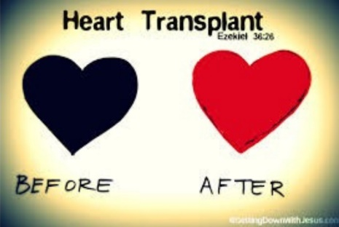  Post-it Challenge:  ‘Prepare the Way of the Lord’  If I am ready to let Jesus into my heart, then will I change my behaviour and the way I treat others?  - How will I make room for Jesus in my life?  Consider: your thoughts, your words, your actions…  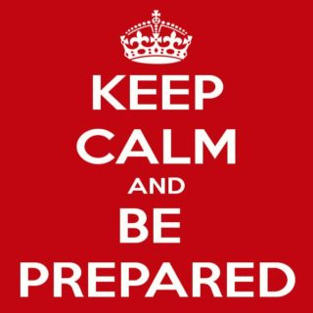  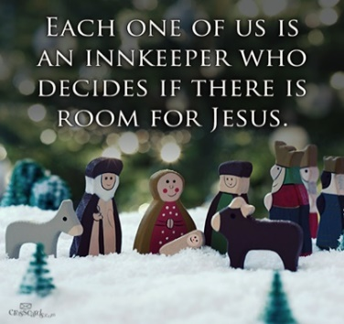  When you become the person Jesus wants you to be the impact on those around you will be huge.  - What do you think you could do  differently to be ready for Jesus this Christmas?  - Is the message of John the Baptist still relevant today?  - Am I greedy for material possessions  or for justice and truth? |   An Advent Prayer  “Prepare the Way of the Lord”  In this season of Advent,  as we wait in joyful hope  for the coming of your Son,  Let us take time to pause in our busy lives,  to prepare our hearts and minds.  Let your light shine within us  So that through our actions, we may offer  hope, justice and truth to everyone we  meet, especially to those in need. Amen

